1. Setup Workday HR/PY Admin user
   1. Note that the user must have an employee record in GV.

IT709 Person ID = Workday Employee ID (of HR/PY Admin user).

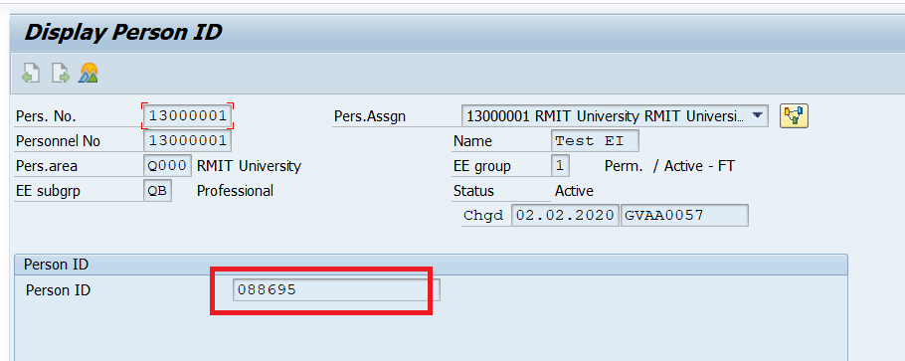

1. Assign authorization roles to Workday HR/PY Admin user
   1. Maintain table ZXADP_SWX_CLROLC

Maintain the roles that you will eventually need to assign to the admin user.

Note that the role ZC_999_99_CULP_ADMIN is mandatory and must always be assigned in addition to the country specific access role.

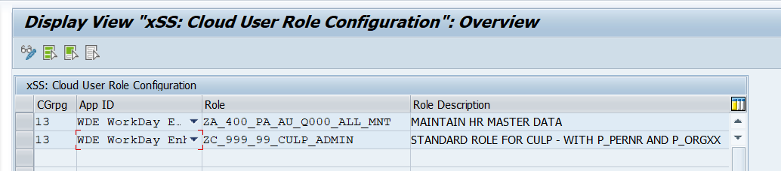

* 1. Maintain table ZXADP_SWX_CLROLA to assign the roles to the HR/PY Admin user.
     + - PersNo = the PERNR of the SAP employee record of the Admin user.
       - App ID = W Workday
       - Role = the access role they are entitled to maintain + the generic ZC_999_99_CULP_ADMIN role
       - Cloud User ID will only be generated **AFTER** CULP has been run so you do not need to enter anything.
       - Employee Name and Role Description will be defaulted in so you do not need to enter anything.

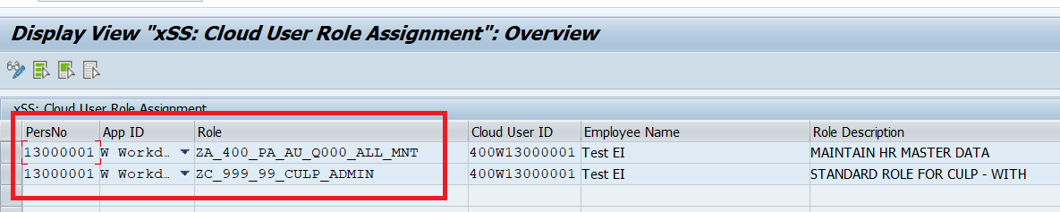

1. Run CULP program (transaction ZADP_M99_CLDUSRCR)

**NOTE:** You will need access to the role ZGVE_AU_9_99_1_XSS_USER_MGMT in order to run CULP. This can be requested via IaAM self service.

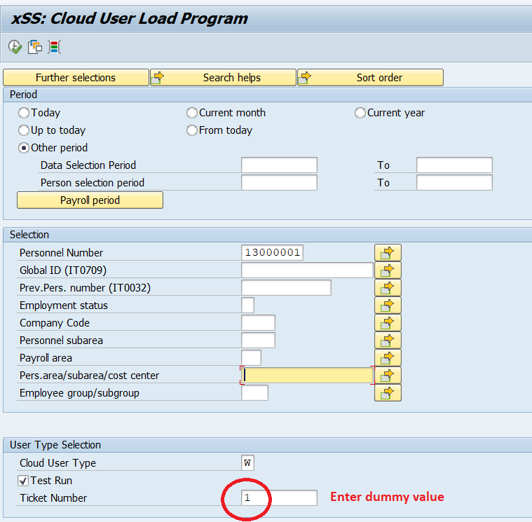

Message should say that it is able to create a cloud User (ignore the example below).

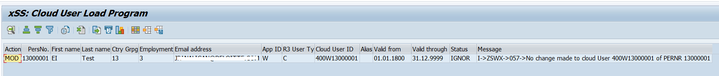

Then execute by removing the Test Run.

HR/PY Admin User should now have necessary roles to test Enhanced Integration.

**Testing process**

1. Client to log in to Workday as the HR/PY Admin user they have nominated. Example Workday EE ID 088695
2. Client to navigate to “Maintain Local Payroll Data” within Workday. This is where Enhanced Integration infotypes should be displayed.
3. Client to search for an employee record in Workday:
   * 1. That they have authorisation to maintain
     2. This employee MUST have also successfully been loaded/hired into GV

If all is successful, client should be able to see the below screen with the relevant enhanced integration infotypes.

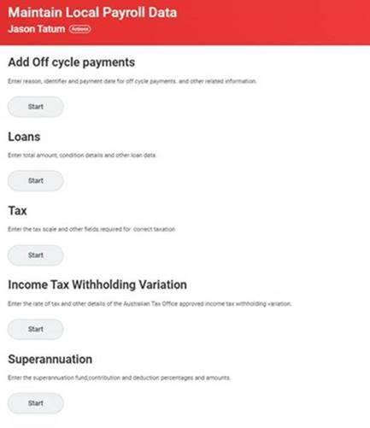

**Troubleshooting in SAP**

1. Check the Audit Log (transaction ZTADP_WDEI_AUDIT) for any errors

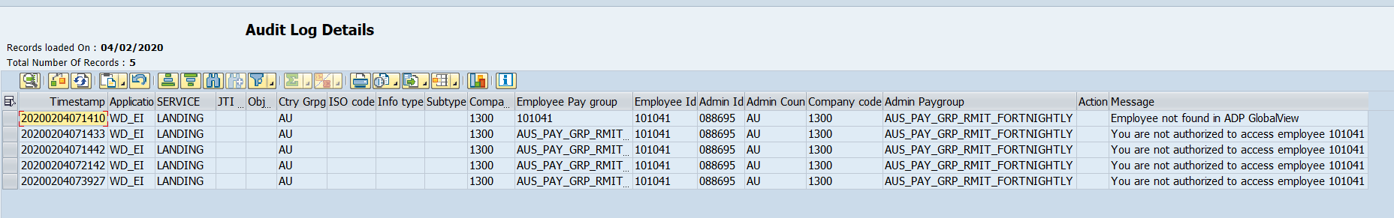

Once the above is all set up, implementation consultant can test in GV as follows:

1. Transaction SE37

Execute the function module ZXADP_M99_CON_PERS_INIT_PAGE

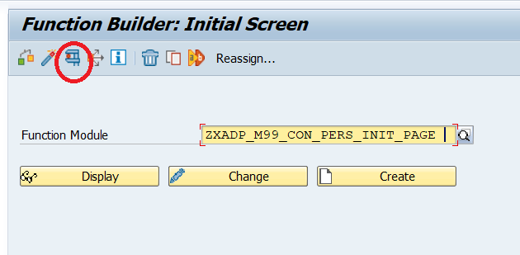

1. Enter the testing criteria

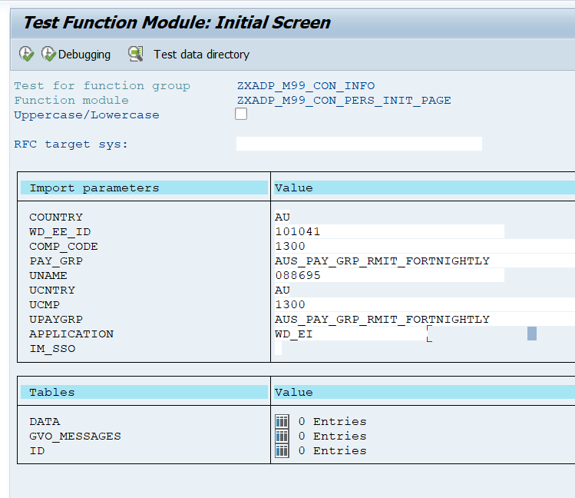

Fields prefixed with “U” is referring to the HR/PY Admin user.

From example above, Admin User 088695 is viewing EE 101041 employee record.

Whilst we do not have the actual Enhanced Integration view from Workday, the below shows that the connection is successful with 5 Infotypes being available.

If there are errors, they will appear in GVO_MESSAGES.

